**Reflection Statement**

It was an interesting exercise to perform a similar-yet-different analysis collaboratively with a group, I found it helpful in providing a more complete understanding of the data even though my own exploration was limited to a single county. This was valuable because although we shared a common aim of investigating how masking policies changed the progression of confirmed COVID-19 cases, many of the specifics related to mask compliance, mandate enforcement, and cases testing & reporting were influenced heavily by local and state level policies and attitudes on the pandemic.

The initial preprocessing and standardization of the data remained relatively consistent across the group, where different analysis techniques and assumptions came into play started with the presence (or lack thereof) of mask mandates. Although my county had a mandate, it was not implemented until after the NYTimes mask compliance snapshot taken July 2-14, 2020. I spoke with Grant Savage who mentioned that his county never implemented a mask mandate, we discussed the difficulty in modeling mask compliance from a single datapoint taken without a mandate in effect. I also chatted with Mitch Haldeman on how best to interpret order_code in the CDC dataset – it was interesting to compare the distribution of order_code and Face_Masks_Required_in_Public. This conversation was helpful because the order_code did not have a definition in the CDC data dictionary and led to my assumption that public mask mandates were only in effect when order_code = 1

I also appreciated the class discussion on how to define infection rate – I found Patrick Peng’s suggestion of using the [Wikipedia](https://en.wikipedia.org/wiki/Infection_rate) definition helpful because number of infections over at-risk population is something that can be easily extended in A5 if we bring in more data. The simplifying assumptions I made regarding at-risk population total can be easily modified by integrating a more accurate total population, vaccination rate, and death count in future analysis.

When visualizing the derivative function or change in slope over time – I found the plotting the daily infection rate introduced a lot of noise, likely due to increased case reporting on Mondays. I’ve seen smoothed COVID-19 case count or infection rate visuals elsewhere but was unsure how to easily implement this myself. When looking at the class Slack, I saw Grant had posted a code snippet that allowed for easy calculation (df.column.rolling(window=7).mean().round()). This introduced me to the [rolling method](https://pandas.pydata.org/docs/reference/api/pandas.DataFrame.rolling.html) which I also used elsewhere in my analysis and will definitely find handy in the future.

See *Figure 1* for a look at the estimated infection rate in Marion County (blue dashes) and a projected infection rate if no mask mandate was implemented (red line). This is not my main plot as I thought the simplifying assumptions here were less robust than the plot I ultimately used, but this will be the type of analysis I hope to refine further. I made this decision after a conversation with Sai Muktevi – we were discussing the pros and cons of different visualizations we had each produced and I decided to save this one for later. Although visualization-specific impact of the collaborative process of this analysis was my decision to highlight the presence of a mask mandate through a yellow background in each plot. When I started this analysis, I had visualized the mask mandate by changing the lineplot color when it was in effect. However, in the thread started by Aaliyah Hanni on how to show mask use in a visualization, I saw that others had employed this background shading effect and felt it was more impactful.

Overall, taking a collaborative approach to this common analysis allowed for a better understanding of potential approaches and insight into the kinds of assumptions others made in their process. I look forward to continuing to expand on this project and see how we can better answer the question of the impact of mask mandates on COVID-19 infection rate.

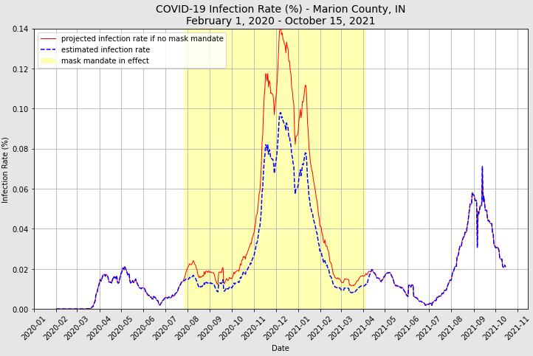

Figure